Graphs of Logarithmic Functions

Key Points:
• The graph of the parent function $f\left(x\right)=\log_{b}{x}$ has an $x-$intercept at ($1,0)$, key point $\left(b,1\right)$, domain $\left(0,∞\right)$, range $\left(-∞,∞\right)$, vertical asymptote $x=0$ and

◦ if $b>1$, the function is increasing.
◦ if $0<b<1$, the function is decreasing

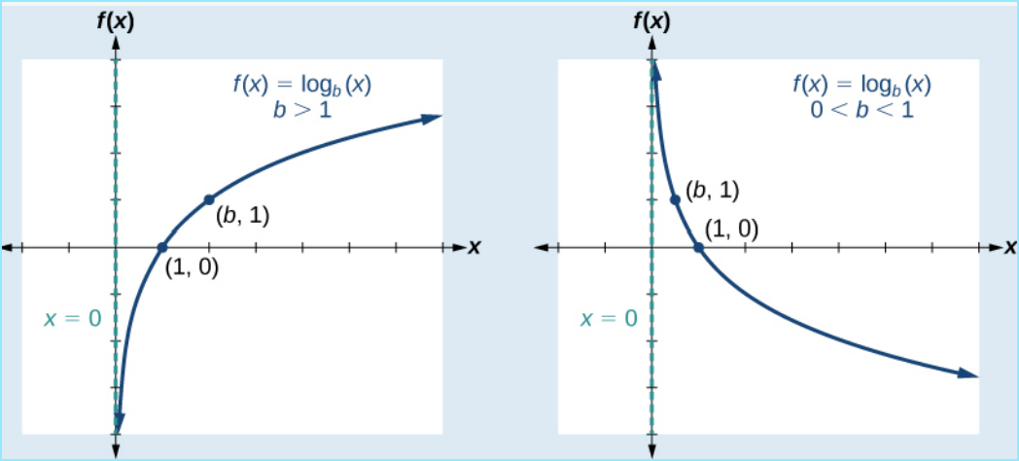

- The equation$f\left(x\right)=\log_{b}\left(x+c\right)$ shifts the parent function $y=\log_{b}{(x)}$ horizontally
◦ left $c$ units if $c>0$.
◦ right $c$ units if $c<0$.
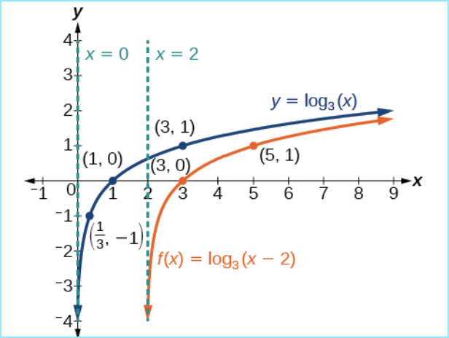

- The equation $f\left(x\right)=\log_{b}\left(x\right)+d$ shifts the parent function $y=\log_{b}{(x)}$ vertically
◦ up $d$ units if $d>0$ .
◦ down $d$ units if $d<0.$
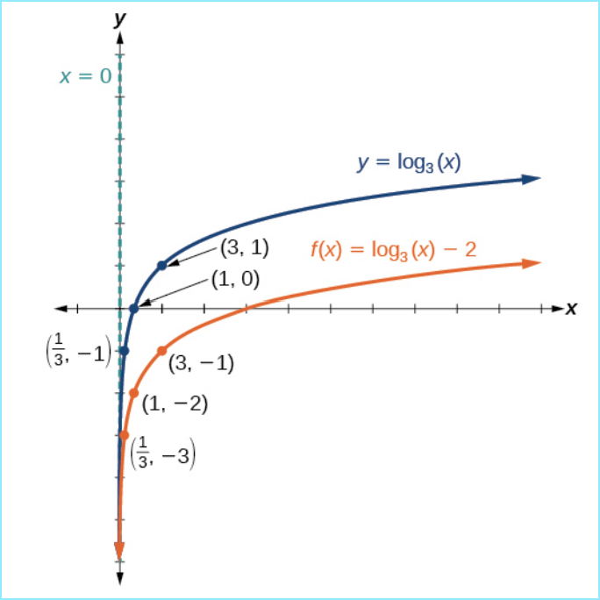
- For any constant $a>0,$the equation $f\left(x\right)=a \log_{b}\left(x\right)$
◦ stretches the parent function $y=\log_{b}\left(x\right)$ vertically by a factor of$a$ if
$\left|a\right|>1$ meaning if $a>1$ or $a<-1.$
◦ compresses the parent function $y=\log_{b}\left(x\right)$ vertically by a factor of $a$ if
$\left|a\right|<1$ , meaning if $-1<a<1$
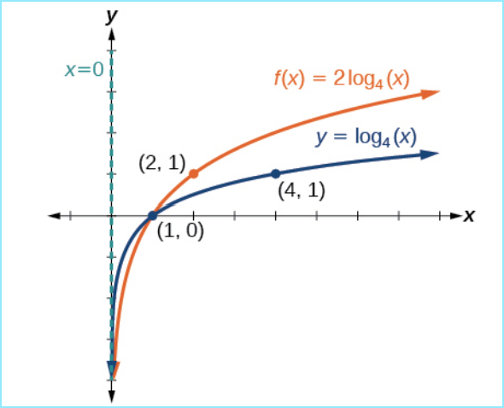

- The equation $g\left(x\right)=-\log_{b}\left(x\right)$represents a reflection of the parent function $f(x)=\log_{b}{(x)}$ about the $x$-axis.

- The equation $h\left(x\right)=\log_{b}\left(-x\right)$ represents a reflection of the parent function $f(x)=\log_{b}{(x)}$about the $y$-axis.

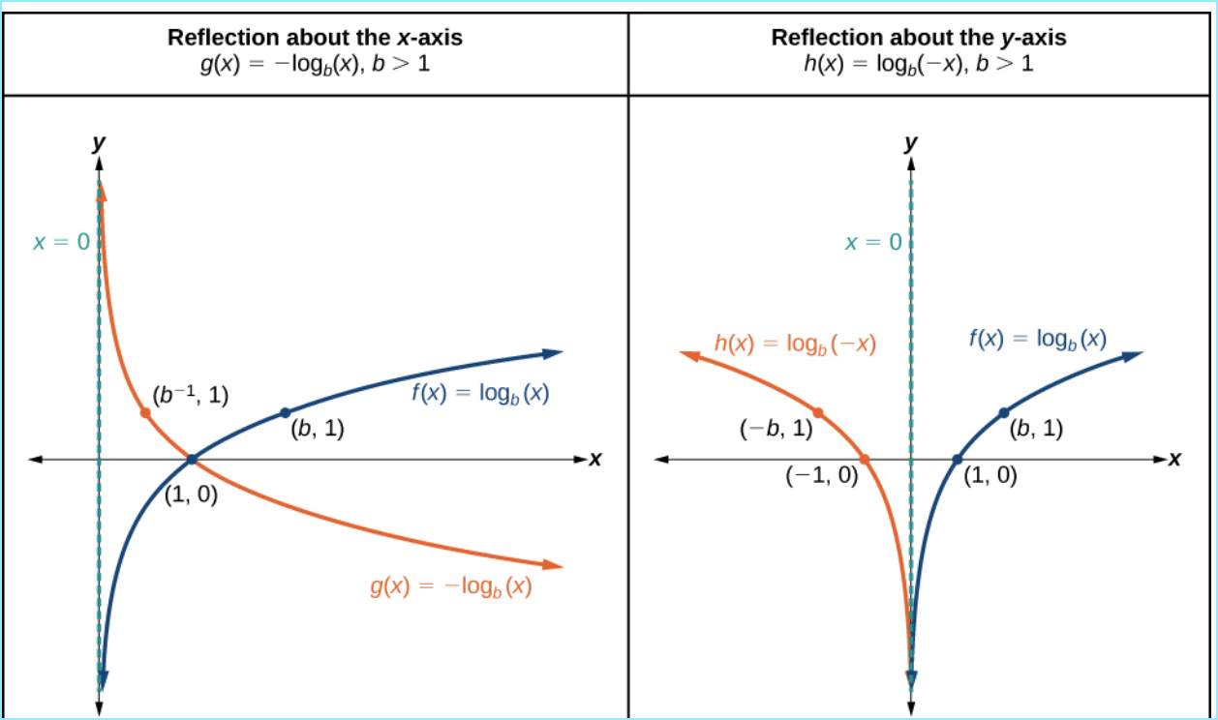

Graphs of Logarithmic Functions Videos
- Graphing a Logarithmic Function of the form $y=\log_{b}{(x): Example 1}$
- Graphing a Horizontal Shift of a Logarithmic Function: Example 2
- Graphing a Vertical Shift of a Logarithmic Function: Example 3
- Graphing a Stretch or Compression of Logarithmic Function: Example 4
- Combining a Shift and a Strech for the Logarithmic Function: Example 5
- Combining a Shift and a Strech for the Logarithmic Function: Example 6
- Graphing a Reflection of a Logarithmic Function: Example 7

Practice Exercises
Follow the directions for each exercise below:
- Match each function in the figure below with the letter corresponding to its graph
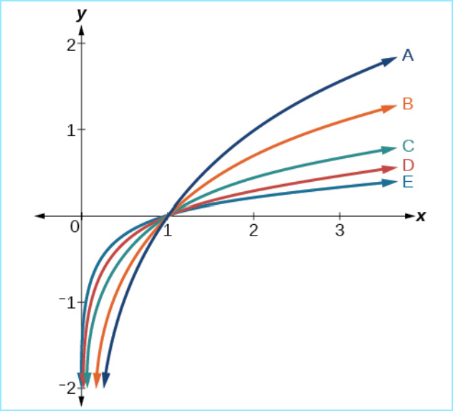
$$d\left(x\right)=\log{(x)}$$
$$f\left(x\right)=\ln\left(x\right)$$
$$g\left(x\right)=\log_{2}\left(x\right)$$
$$h\left(x\right)=\log_{5}\left(x\right)$$
$$j\left(x\right)=\log_{25}\left(x\right)$$
- Match each function in the figure below with the letter corresponding to its graph.

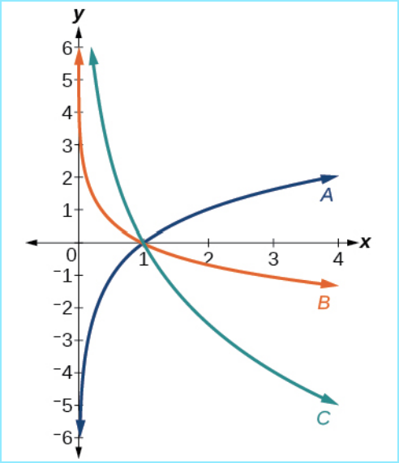

$$f\left(x\right)=\log_{1/3}\left(x\right)$$
$$g\left(x\right)=\log_{2}\left(x\right)$$
$$h\left(x\right)=\log_{3/4}{(x)}$$
- Match each function in the figure below with the letter corresponding to its graph.

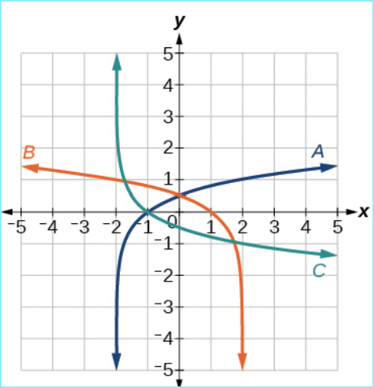

$$f\left(x\right)=\log_{4}\left(-x+2\right)$$
$$g\left(x\right)=-\log_{4}\left(x+2\right)$$
$$h\left(x\right)=\log_{4}\left(x+2\right)$$

For the following exercises, sketch the graph of the indicated functions and state their domain, range and vertical asymptotes.
- $f\left(x\right)=\log_{2}\left(x+2\right)$

- $f\left(x\right)=2\log{(x)}$

- $f\left(x\right)=\ln\left(-x\right)$

- $h\left(x\right)=-\frac{1}{2}\ln\left(x+1\right)-3$

Answers:
- $A→$ $g(x)$, $B→ f(x)$, $C→h(x)$, $D→:d(x)$, $E→j(x)$

- $A→g(x)$, $B→f(x)$, $C→h(x)$

- $A→h(x)$, $B→f(x)$, $C→g(x)$

- Domain: $(-2.∞)$, Range: $\left(-∞,∞\right)$, vertical asymptote: $x=-2$
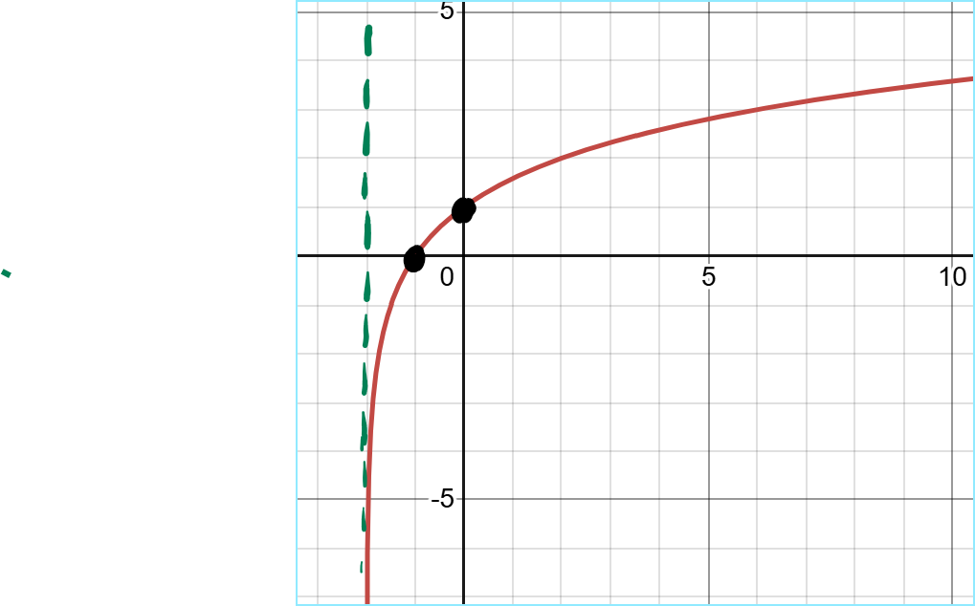
- Domain: $\left(0,∞\right)$, Range: $\left(-∞,∞\right)$, vertical asymptote: $x=0$
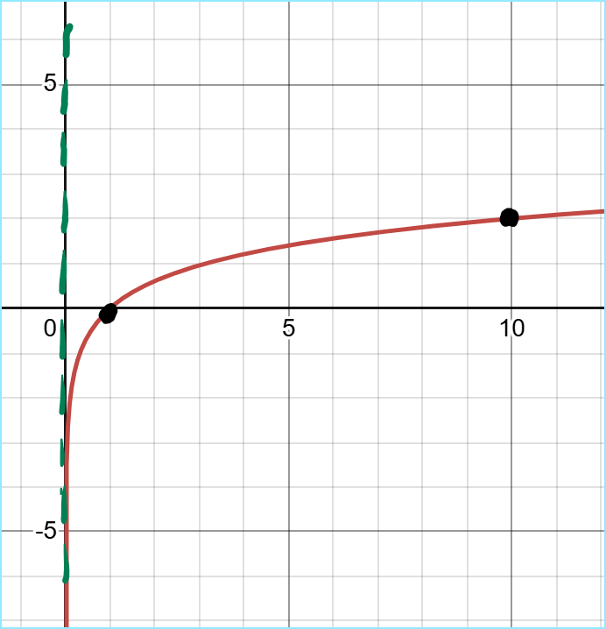

- Domain: $\left(-∞,0\right),$Range: $\left(-∞,∞\right)$, vertical asymptote: $x=0$
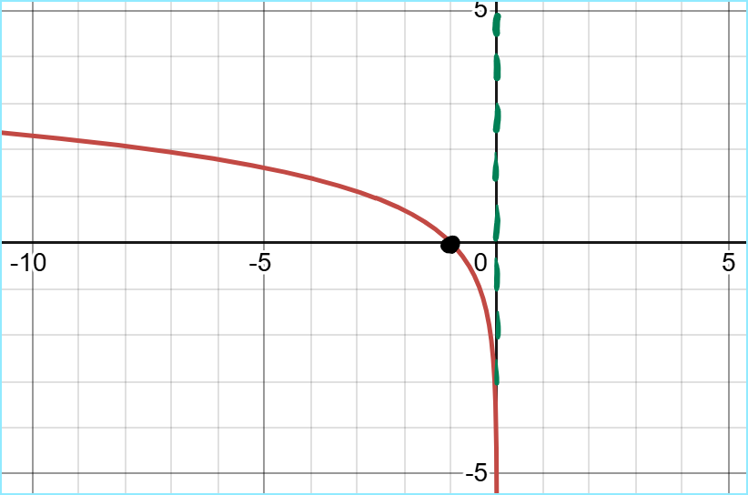

- Domain:$(-1,∞)$ Range:$\left(-∞,∞\right)$ Vertical asymptote:$x=-1$
